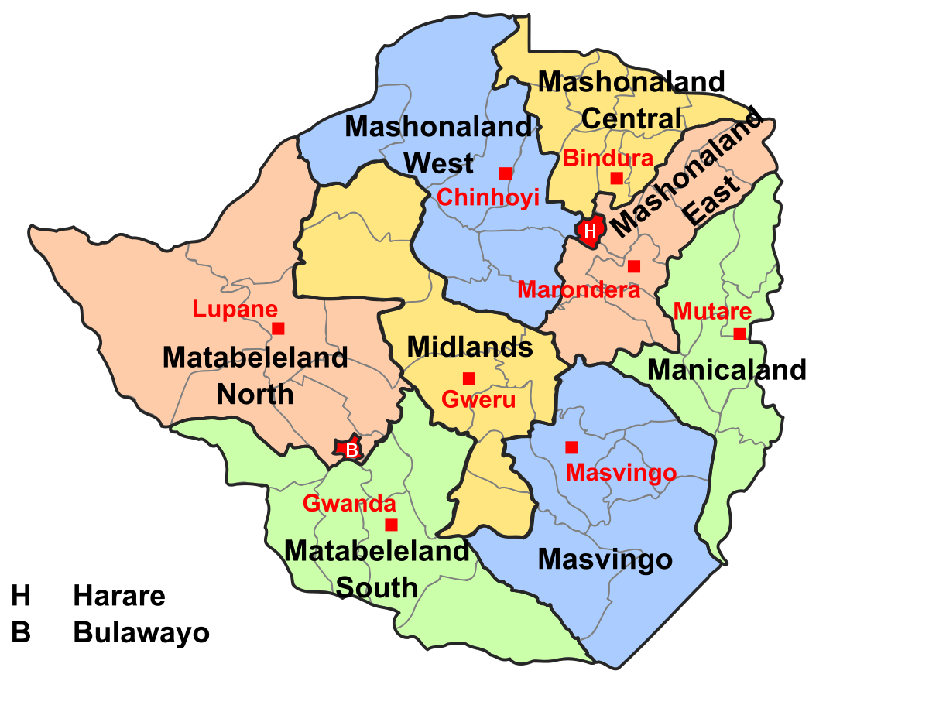 26 February 2021
Consumer Price Index (FEBRUARY 2019 = 100) – FEBRUARY 2021

The month on month inflation rate in February 2021 was 3.45 percent shedding 1.98 percentage points on the January 2021 rate of 5.43 percent. (See note on period of data collection below).
This means that prices as measured by the all items CPI increased by an average rate of 3.45 percent from January 2021 to February 2021.

- The month-on-month inflation rate is given by the percentage change in the index of the relevant month of the current year compared with the index of the previous month in the current year.

The month on month Food and Non Alcoholic Beverages inflation rate stood at 4.42 percent in February 2021, shedding 3.42 percentage points on the January 2021 rate of 7.84 percent. The month on month non-food inflation rate stood at 2.73 percent, shedding 0.97 percentage points on the January 2021 rate of 3.70 percent.

The CPI for the month ending February 2021 stood at 2, 698.89 compared to 2, 608.79 in January 2021 and 640.16 in February 2020.

The year on year inflation rate (annual percentage change) for the month of February 2021 as measured by the all items Consumer Price Index (CPI) stood at 321.59 percent.

This means that prices as measured by the all items CPI increased by an average of 321.59 percent between February 2020 and February 2021.

The year-on-year inflation rate is given by the percentage change in the index of the relevant month of the current year compared with the index of the same month in the previous year.

- Period of Data Collection

It is important to note that data on prices was collected during the period from 11 to 17 February 2021.The changes in prices in this report refer to that period of data collection.

THE NEW CONSUMER PRICE INDEX

With effect from March 2019 ZIMSTAT is publishing the new Consumer Price Index (CPI) with new weights and a classification. The use of a Classification of Individual Consumption by Purpose (COICOP) resulted in the creation of a new classification which resulted in coming up with 83 classes, 41 groups and 12 divisions. The number of items in the CPI basket is 495.

The implementation of the COICOP classification is also part of the harmonisation project of Consumer Price Indices in different regions like the SADC region. All member states are supposed to adopt the new procedure to enable inter country comparisons of the CPI and the rate of inflation. The new weights are therefore applicable from February 2019 onwards.

Mean Month on Month Rates

The mean month on month inflation rate for the period January to December 2020 was 13.8 percent while the mean month on month inflation rate for the same period in 2019 was 17.0 percent.
The month on month inflation rate from January to February 2021 was 4.4 percent.

Contact us
Tel : 706681/7
E-mail : prices@zimstat.co.zw

Table 1: Month on month inflation rate from February 2020 to February 2021
Months | Feb-20 | Mar-20 | Apr-20 | May-20 | Jun-20 | Jul-20 | Aug-20 | Sep-20 | Oct-20 | Nov-20 | Dec-20 | Jan-21 | Feb-21
Month on month inflation rate | 13.5 | 26.6 | 17.6 | 15.1 | 31.7 | 35.5 | 8.4 | 3.8 | 4.4 | 3.2 | 4.2 | 5.4 | 3.5

Figure 1: Month on month inflation rate from February 2020 to February 2021

